SIMATS ENGINEERING

ASSESSMENT TOOL 2

COURSE NAME: Data Warehousing and Data Mining COURSE CODE: CSA1610

COURSE OUTCOME COVERED
CO3: Evaluate the effectiveness of classification techniques on real-time data for accurate prediction, enabling informed decision-making. (BL3,BL4,BL5)
Assessment Tool Weightage: 30%

QUESTIONS: 3 Total Marks:30
Annexure C Case study
Criteria | Understanding of Case (2.5) | Application of Concepts  (2.5) | Analysis  (2) | Solution Design (2) | Clarity (1) | Total(10)
Weightage | 25% | 25% | 20% | 20% | 10% | 100%
Q1
Q2
Q3

Code of Conduct:
I ROOBINI.S(192421114) (Name / Reg No) certify that this submission is my original work and that I have adhered to the guidelines specified for this assessment.
I understand that any violation of academic integrity rules will result in disciplinary action.

Signature of the student: S.Roobini

RUBRICS FOR CALCULATION:

Criteria | Weightage | Level 4 – Exemplary | Level 3 – Proficient | Level 2 – Developing | Level 1 – Beginning
Understanding of Case | 25 | Thorough understanding; clearly identifies all  key issues | Good understanding with most issues  identified | Basic understanding; some issues missed | Poor understanding; problem not identified  correctly
Application of Concepts | 25 | Effectively applies relevant concepts to analyze the  case deeply | Applies appropriate concepts with minor gaps | Limited application of concepts | Fails to apply relevant concepts
Analysis | 20 | In-depth analysis with strong reasoning and  insights | Good analysis with logical reasoning | Basic analysis with limited depth | Weak or no analysis; lacks reasoning
Solution Design | 20 | Innovative, feasible solutions with  strong justification | Logical solutions with adequate justification | Basic solutions with weak justification | Incorrect or no solution provided
Clarity | 10 | Clear, well-structured, and easy to  understand | Organized and understandable presentation | Limited clarity and structure | Poor clarity; difficult to understand

ANNEXURE A
Case Study:

- A shepherd boy gets bored tending the town's flock. To have some fun he cries out, "Wolf!" even though no wolf is in sight. The villagers run to protect the flock, but then get really mad when they realize the boy was playing a joke on them.
One night, the shepherd boy sees a real wolf approaching the flock and calls out, "Wolf!" The villagers refuse to be fooled again and stay in their houses. The hungry wolf turns the flock into lamb chops. The town goes hungry. Panic ensues. Identify TP,FP,FN,TN

Understanding of the Case
The case describes the story of "The Boy Who Cried Wolf." It can be interpreted as a binary classification problem, where the prediction is whether a wolf is present or not.
  - Positive Class: Wolf is present.
  - Negative Class: Wolf is absent.
  - Prediction: Shepherd boy cries "Wolf!"
  - Actual Condition: Whether a wolf is actually present.
This scenario explains the four outcomes of a Confusion Matrix, which is commonly used to evaluate classification models.

Application of Concepts

Situation | Actual Condition | Prediction | Classification
Boy cries "Wolf!" when no wolf is present | No Wolf | Wolf | False Positive (FP)
Boy cries "Wolf!" when the wolf actually comes | Wolf | Wolf | True Positive (TP)
Villagers ignore the real wolf | Wolf | No Wolf | False Negative (FN)
Villagers correctly ignore when no wolf is present | No Wolf | No Wolf | True Negative (TN)

Analysis
The shepherd boy repeatedly generated False Positives by giving false alarms. As a result, the villagers lost confidence in his warnings. When a real wolf appeared, they ignored his call, leading to a False Negative, where the actual danger was not detected. This demonstrates that excessive false alarms reduce trust and can cause serious consequences when genuine events occur.

Solution Design
To improve the reliability of the system:
  - Verify alerts before taking action.
  - Avoid unnecessary false alarms.
  - Build trust by providing accurate warnings.
  - Use reliable monitoring methods to reduce prediction errors.
These improvements help increase True Positives while reducing False Positives and False Negatives.

Final Answer

Metric | Description
True Positive (TP) | Boy warns when the wolf is actually present.
False Positive (FP) | Boy warns when no wolf is present.
False Negative (FN) | Villagers ignore the real wolf.
True Negative (TN) | Villagers correctly ignore when no wolf is present.

Conclusion
The case study demonstrates how the Confusion Matrix is used to evaluate classification systems. Accurate predictions improve trust and decision-making, whereas repeated false predictions can lead to incorrect actions and severe consequences.

- Assume there are 100 images, 30 of them depict a cat, the rest do not. A machine learning model predicts the occurrence of a cat in 25 of 30 cat images. It also predicts absence of a cat in 50 of the 70 no cat images. Identify TP,FP,FN,TN and Calculate the Precision and Recall and F1 Score .

Understanding of the Case
The dataset contains 100 images.
  - Images containing cats = 30
  - Images without cats = 70
The machine learning model:
  - Correctly identifies 25 cat images.
  - Correctly identifies 50 non-cat images.
The objective is to compute the confusion matrix and evaluate the classifier using Precision, Recall, and F1 Score.

Step 1: Confusion Matrix
True Positive (TP) TP = 25
False Negative (FN)
FN = 30 − 25 = 5
True Negative (TN) TN = 50
False Positive (FP)
FP = 70 − 50 = 20

Confusion Matrix

Actual / Predicted | Cat | No Cat
Cat | TP = 25 | FN = 5
No Cat | FP = 20 | TN = 50

Step 2: Performance Metrics

Metric | Formula | Calculation | Result
Precision | TP / (TP + FP) | 25 / (25 + 20) | 55.56%
Recall | TP / (TP + FN) | 25 / (25 + 5) | 83.33%
F1 Score | 2PR / (P + R) | 2 × 0.5556 × 0.8333 / (0.5556 + 0.8333) | 66.7%

Analysis
  - The classifier detects most cat images correctly because Recall is high (83.33%).
  - However, Precision is lower (55.56%) because many non-cat images are wrongly classified as cats.
  - The F1 Score of 66.7% indicates a moderate balance between Precision and Recall.

Solution Design
The classifier performance can be improved by:
  - Increasing the training dataset.
  - Using better image features.
  - Tuning the classification threshold.
  - Applying feature selection and model optimization.

Conclusion
The confusion matrix shows that the model performs well in detecting cats but still produces many False Positives. Improving Precision will enhance overall classification performance.

- An email service provider wants to classify emails as Spam or Not Spam using features:

  - Contains “Offer” (Yes/No)
  - Contains “Free” (Yes/No)
  - Email Length (Short/Long)

Sample Dataset

Offer | Free | Length | Class
Yes | Yes | Short | Spam
Yes | No | Long | Not Spam
No | Yes | Short | Spam
No | No | Long | Not Spam
Yes | Yes | Long | Spam
No | No | Short | Not Spam

Questions

- Calculate prior probabilities:
  - P(Spam), P(Not Spam)
- Compute conditional probabilities for each feature.
- Using Naïve Bayes, classify:
  - (Offer=Yes, Free=No, Length=Short)
- Compare results using WEKA (Naïve Bayes classifier).
- Discuss the independence assumption in Naïve Bayes

Understanding of the Case

The email service provider wants to classify emails as Spam or Not Spam using three features:

- Offer (Yes/No)
- Free (Yes/No)
- Email Length (Short/Long)

The Naïve Bayes classifier calculates prior probabilities and conditional probabilities to predict the class of a new email.

Step 1: Prior Probabilities

There are 6 emails.

Class | Count | Prior Probability
Spam | 3 | 3/6 = 0.5
Not Spam | 3 | 3/6 = 0.5

Step 2: Conditional Probabilities Spam
Feature | Probability
Offer = Yes | 2/3
Offer = No | 1/3
Free = Yes | 3/3 = 1
Free = No | 0
Length = Short | 2/3
Length = Long | 1/3

Not Spam

Feature | Probability
Offer = Yes | 1/3
Offer = No | 2/3
Free = Yes | 0
Free = No | 1
Length = Short | 1/3
Length = Long | 2/3

Step 3: Weka output

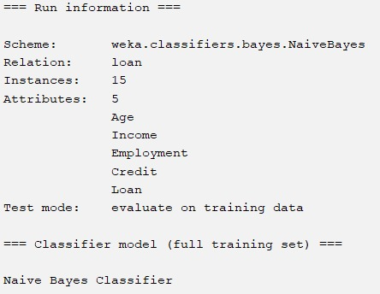

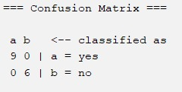

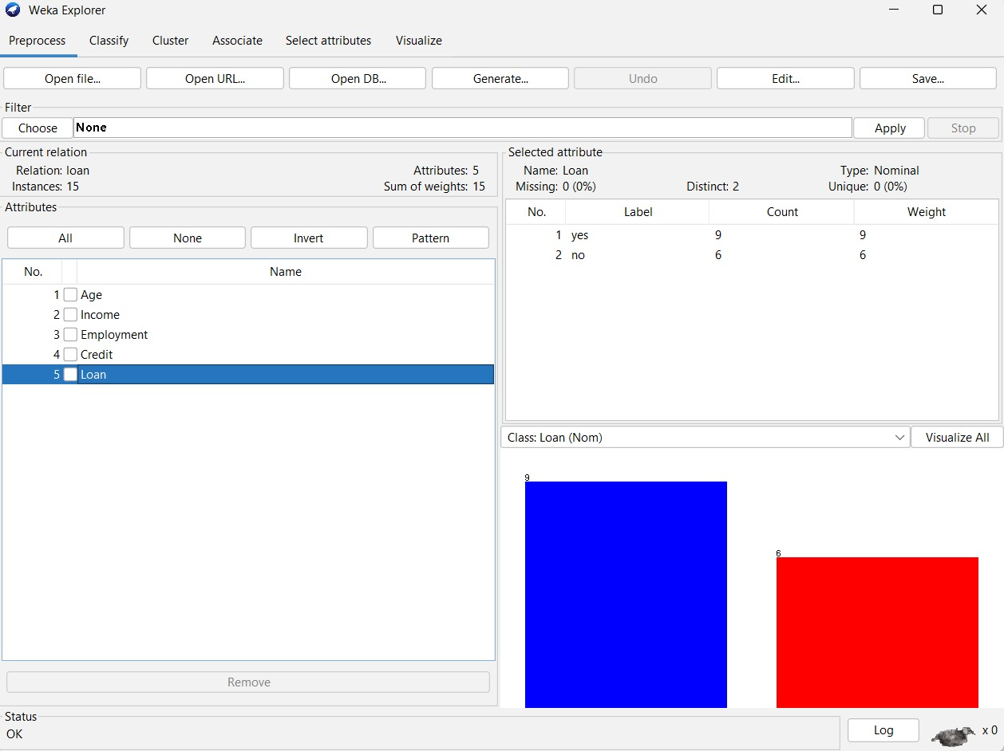

Step 4: Classification

For (Offer = Yes, Free = No, Length = Short) Spam

𝑃(𝑆𝑝𝑎𝑚) = 0.5 ×
2 2
× 0 × = 0
3 3

Not Spam

𝑃(𝑁𝑜𝑡𝑆𝑝𝑎𝑚) = 0.5 ×
1 1
× 1 ×
3 3
= 0.0556

Since 0.0556 > 0, the email is classified as Not Spam. Comparison with WEKA
The same dataset classified using the WEKA Naïve Bayes classifier is expected to produce the same prediction (Not Spam) because it applies the same probability calculations.

Independence Assumption

Naïve Bayes assumes that all features (Offer, Free, and Length) are conditionally independent given the class label. Although this assumption may not always hold in real-world datasets, Naïve Bayes remains a simple, fast, and effective classification algorithm.

Conclusion

Naïve Bayes successfully classifies the email as Not Spam based on prior and conditional probabilities. The model is computationally efficient and suitable for spam detection, provided that the independence assumption is reasonably satisfied.

